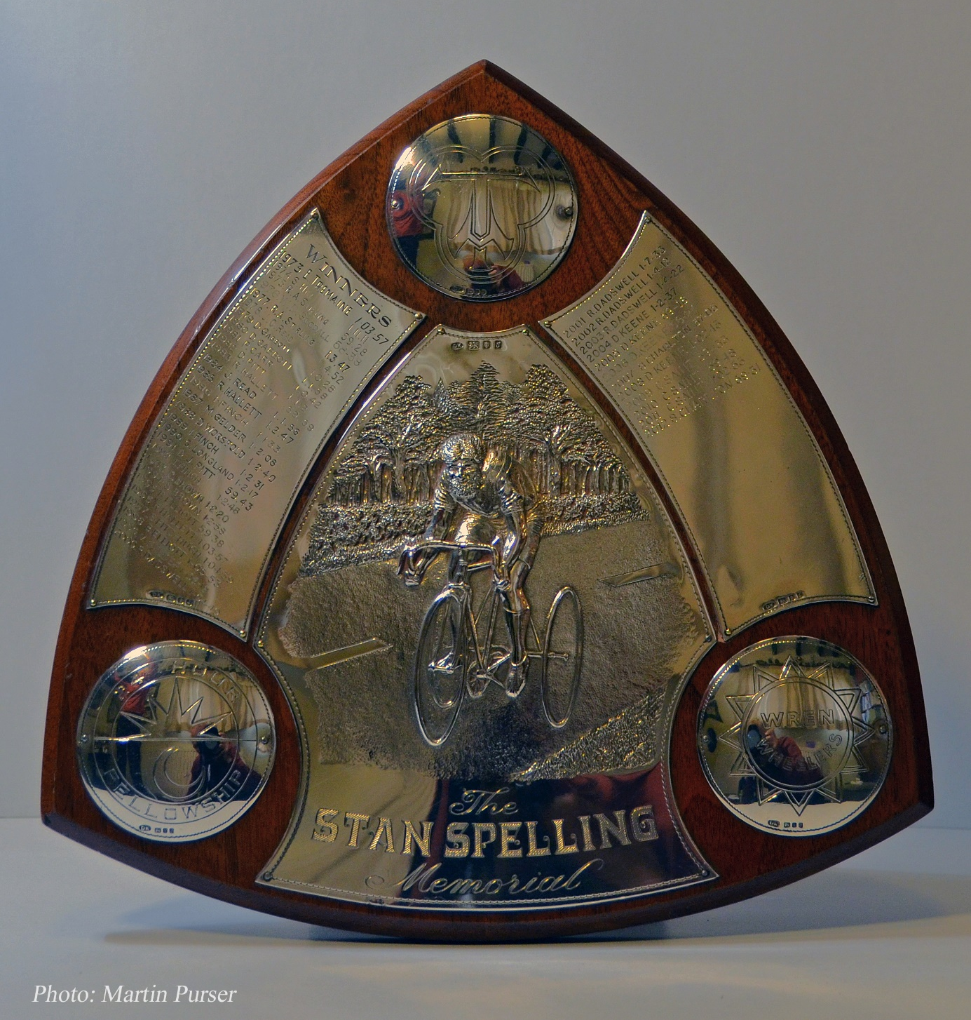
RESULT
The Tricycle Association (North Eastern Region)‘25’
for The T. A. National Championship and ‘Stan Spelling’ Memorial Trophy,
the ‘Bernard Wood’ Memorial Trophy & the ‘Jack Riley’ Memorial Handicap Trophy

Saturday 7th May 2022 Course O25/11
T.A. North Eastern Region ‘25’ for National Championship ‘Stan Spelling’ Memorial Trophy,
and the Regional ‘Bernard Wood’ Memorial Trophy: Dave Mason ~ Lincoln Wheelers
The Regional ‘Jack Riley’ Memorial Handicap Trophy: Steve Brown ~ Ravensthorpe C.C.
Pos. | Name | Club | H’cap | Handicap Time | H’cap Pos. | TIME
1. | Dave Mason | Lincoln Wheelers C.C. | SCR. | 1.03.22 | 3 | 1.03.22
2. | Steve Brown | Ravensthorpe C.C. | 10.00 | 59.10 | 1 | 1.09.10
3. | Lez Young | Lincoln Wheelers C.C. | 11.00 | 1.01.33 | 2 | 1.12.33
4. | Andrew Such | Scunthorpe R.C. | 15.00 | 1.04.48 | 4 | 1.19.48
5. | Alan Shuttleworth | Weaver Valley C.C. | 21.00 |  |  | DQ
 | Wayne Baker | Team Echelon | 16.00 | DNS (Apols)
Result:

Acknowledgements:- Many many thanks to the following:
Philip Minto and John Clark for Timing; Dave Hardy, Ralph Lyon, Christine Minto, Paul Potter Martin Purser and members of Sheffrec C.C. for marshalling; Adam Machan for organising the Sheffrec event, Event HQ, Signs and for Refreshments.
Congratulations:- Dave Mason for winning both the Scratch Trophies with 1h.03m. 22s.; and Steve Brown for winning the ‘Jack Riley’ Trophy.
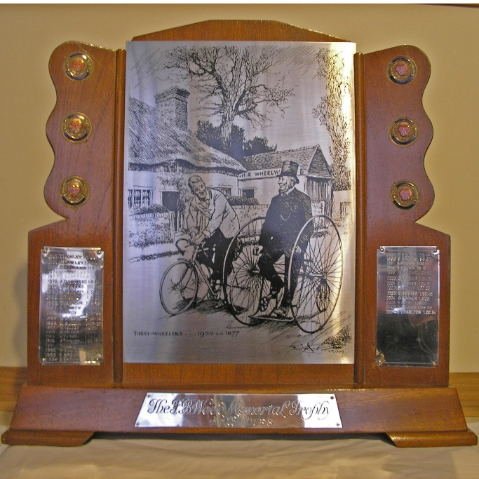
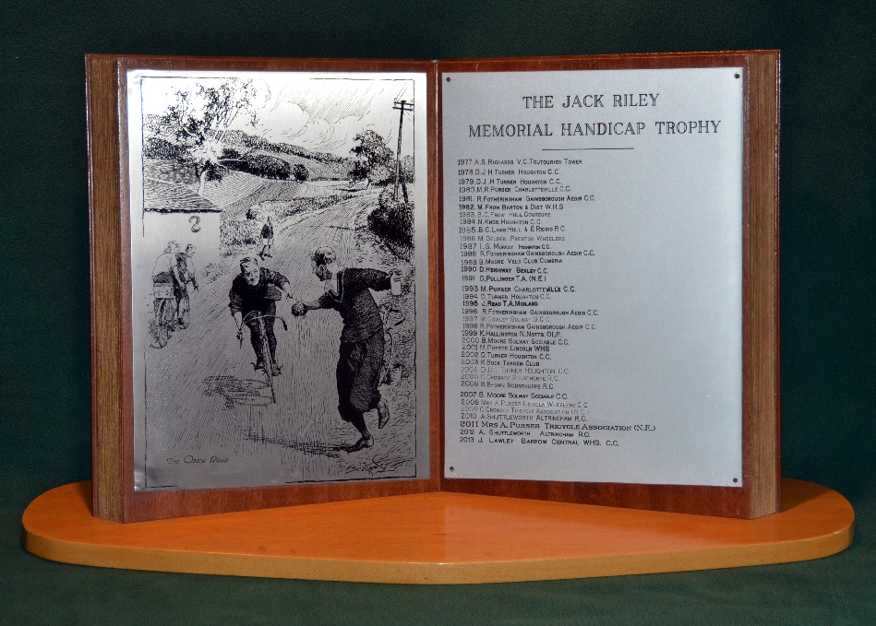
The Medals and ‘Stan Spelling’ Memorial Trophy
will be awarded at
The Tricycle Association Annual Reunion and Prize Presentation
to be held at The Link Hotel, Loughborough
Saturday, 29th October 2022.
Tickets available from Dave Hardy, TA National Captain.

The ‘Bernard Wood’ Memorial Trophy and
The ‘Jack Riley’ Memorial Handicap Trophy
will be awarded at the
Tricycle Association (North Eastern Region) Lunch in January 2023.
Tickets available from Dave Hardy (TA North Eastern Region Captain).

Hon. Event Secretary:
Alison Purser, Ivy House Farm, Silver Street, GRASSTHORPE, Newark, NG23 6QZ
Tel: 01636 821190 trikingpursers@btinternet.com Mobile (on day) 07890 181593

